A.1) The Output would be

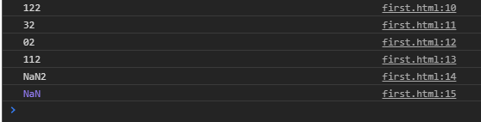

The output would be like this because the numerical written inside double quotes are treated as characters and ++ and +- together signs are used for increment and decrement.